CambridgeSoft Web page ISISDraw Editing Prototype

Nov. 9, 2005, Fred Putnam (with assistance from Churl Oh)

To meet the needs of customers who wich to edit ChemDraw strucutres with ISIS/Draw, where the ChemDraw control is embedded in web pages, we developed a COM component that contains the technology developed for this purpose for E-Notebook, slimmed down so that it can be used outside of E-Notebook.

Contents:

1. CSISISFraw9.dll, the COM component, which must be registered on the client PC.
2. CSISISDraw1.htm, an example web page.

Requirements:

1. The ChemDraw 9 control must be registered on the client PC.
2. Either

A. MDL ISIS Desktop 2.5 SP 1

or

B. ISIS/Draw 2.5, plus the mdlbox.ocx and isislib.dll controls.

To test or demo:

1. Copy the contents to a client PC that has the requirements met.
2. Double-click on the example web page to launch it in Internet Explorer.
3. Double-click on the ChemDraw control rectangle to edit in ISIS/Draw.

You should see the following dialog box:

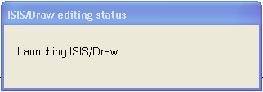

followed shortly by the ISIS/Draw application.

After drawing the structure, hit the Save-and-Close button, shown by the red arrow below, to return the structure the ChemDraw control in the web page.

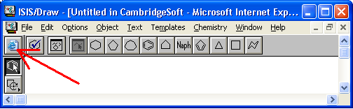

Note: If for any reason ISIS/Draw cannot be launched, the “Launching ISIS/Draw” process will time out after 60 seconds.

